Scenario 4: private subnet servers should not have public facing but they should have an internet access [NAT gateway]
Step 1: lets launch an windows instance in private subnet.
Private Subnet: 10.10.10.0/27
Range: 10.10.10.0 – 10.10.10.31
Usable: 10.10.10.4 – 10.10.10.30 (27 usable IPs)
- Lets use 10.10.10.4 Ip
Step 2:
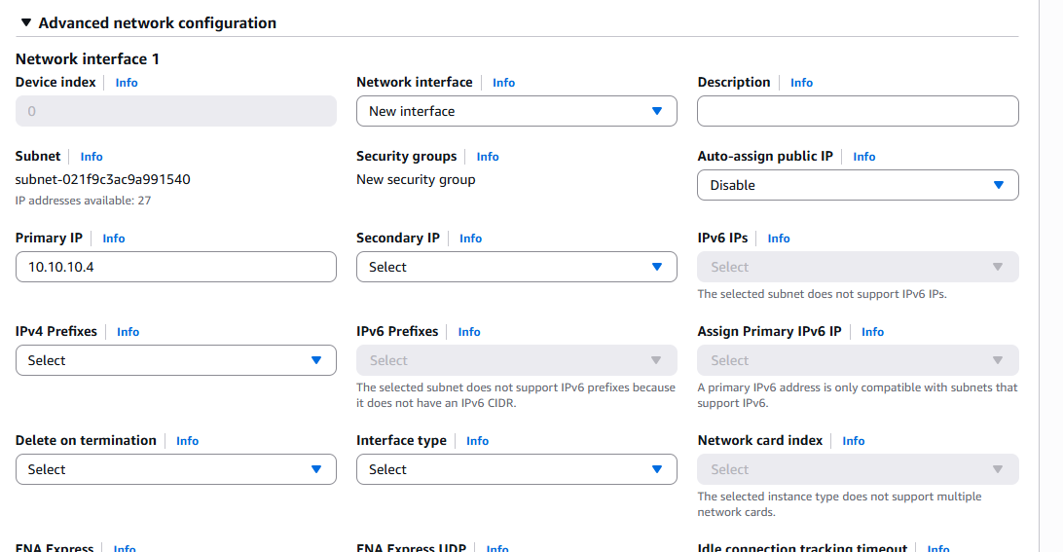
Step 3: inbound rule had https so that we can connect with SSM.ensure ssm role is also attached
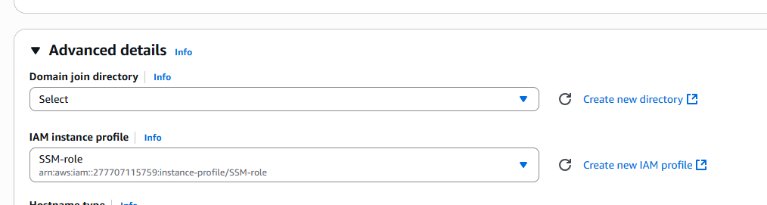
Step 4: provide an static primary ip – 10.10.10.4, under advance Advanced network configuration
Step 5: launch
Step 6: go to the instance > click on connect >
We could see that even though we have attached the iam role and https rule.
We still ssm agent could connect because we instance don’t have internet access.
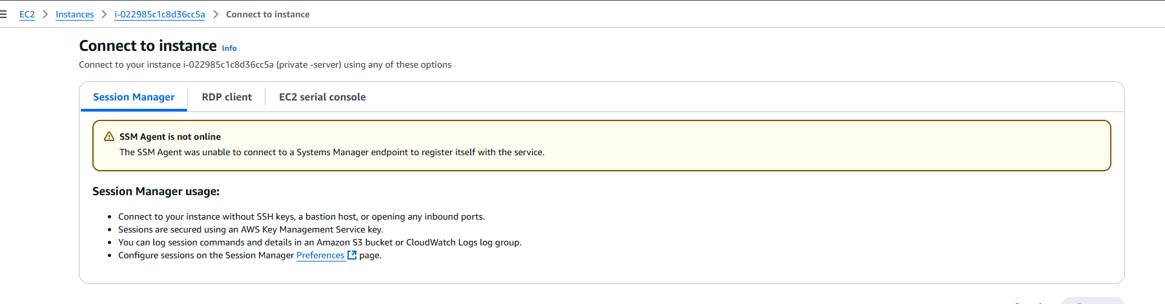
Step 7: since its an private instance in private subnet .
Let’s edit private route table to have target NAT to provide an internet access.
Step 8: go to VPC > in left side panel select > NAT gateways.
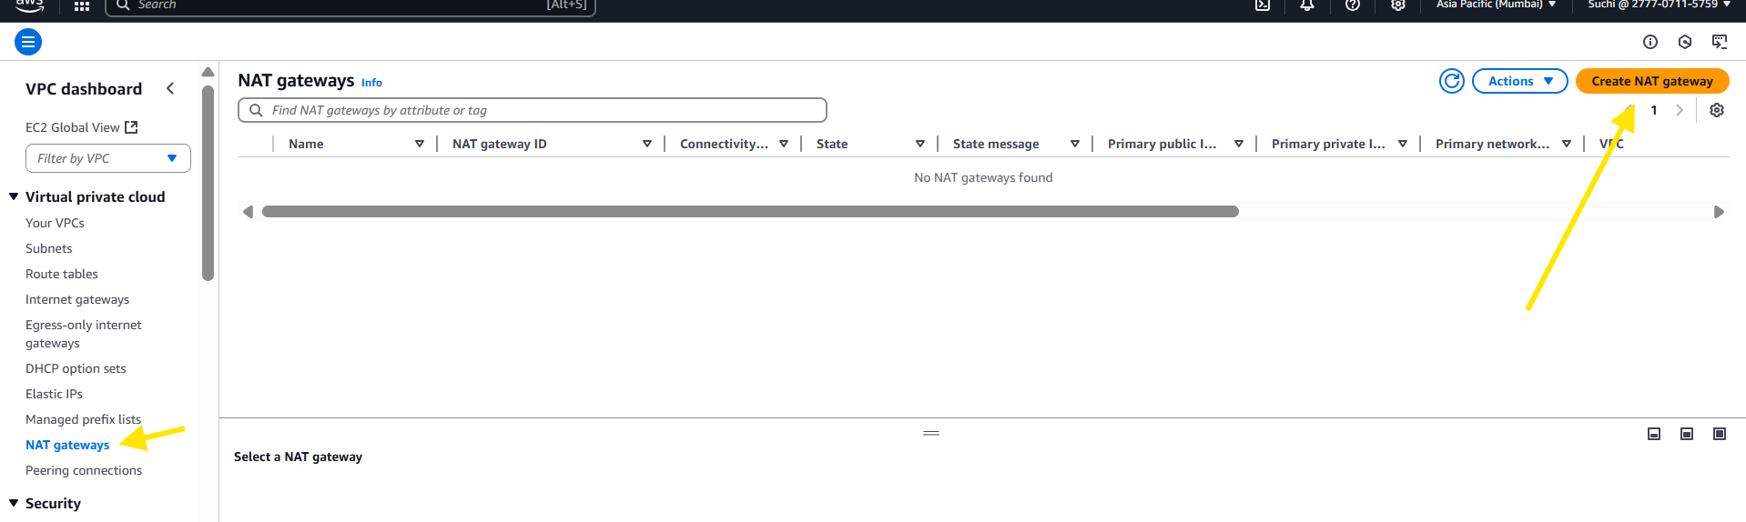

Step 10: click on create NAT gateway.
Note NAT gateway should be in a public subnet with a route to Internet gateway.
Step 11: follow the below snip
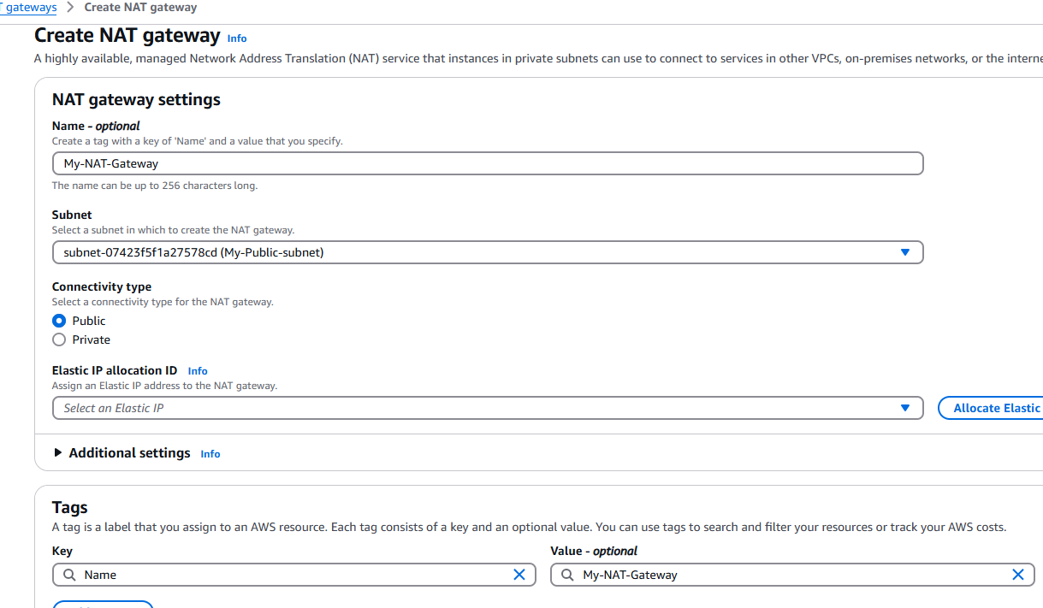
Step 12 : since we don’t have elastic IP, click on Allocate Elastic IP to create one elastic ip.
AWS will automatically create an elastic ip.
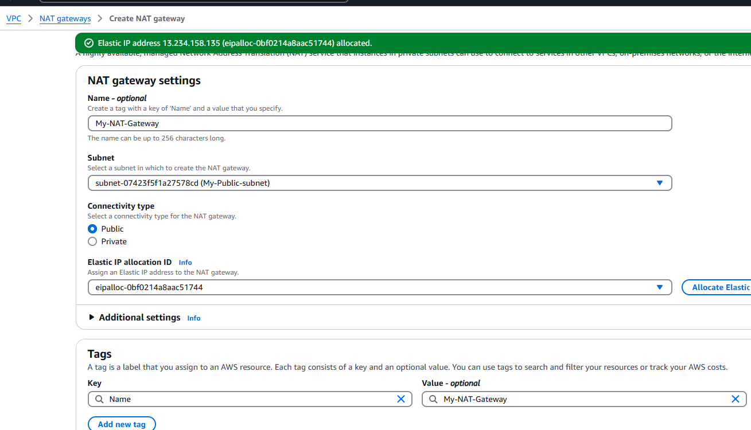
Step 13: click create NAT Gateway

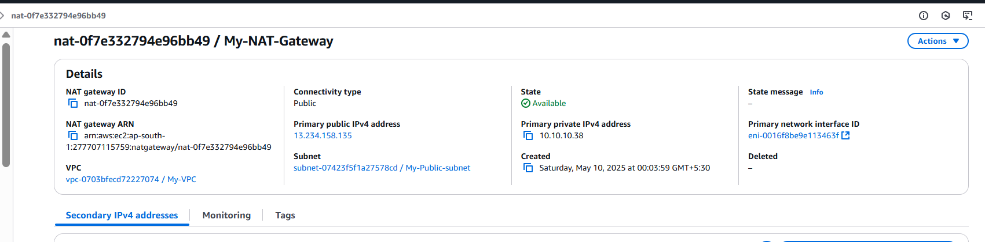
Step 8: go to VPC > in left side pannel select > route tables
Select private route table and scroll down and select Routes.
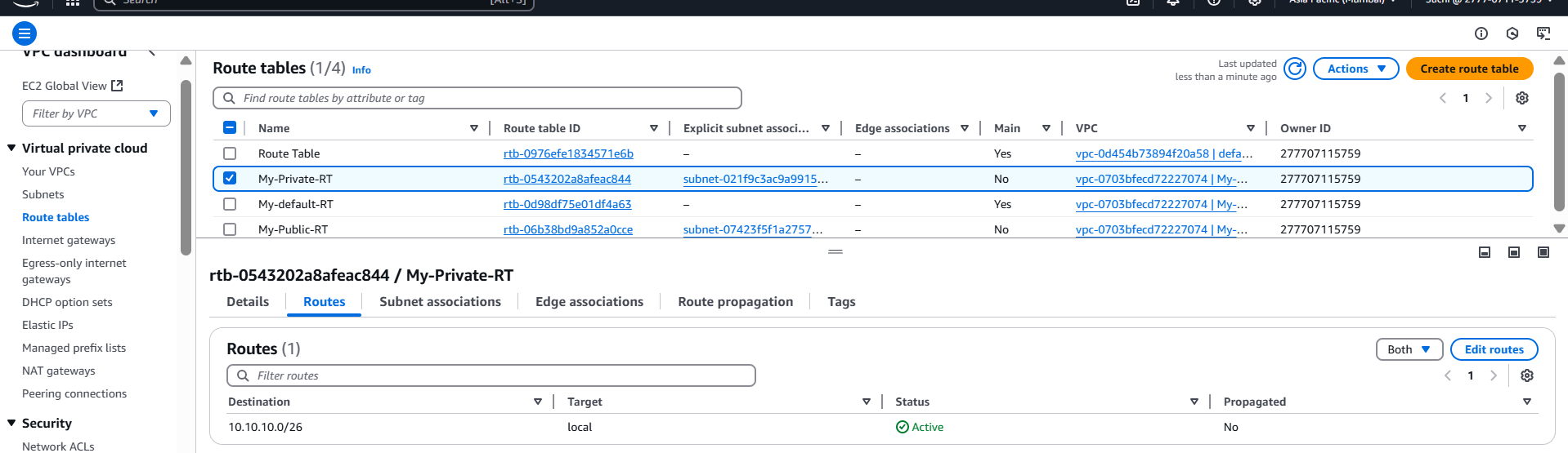

Step 9: click on edit routes .
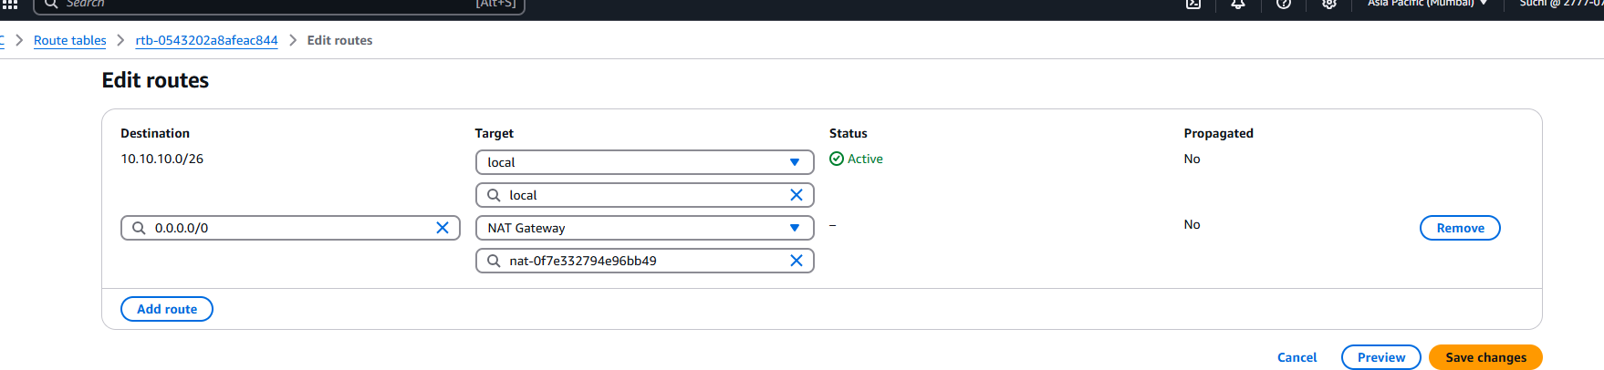
Step 10 : ensure private subnet is associated with private route table
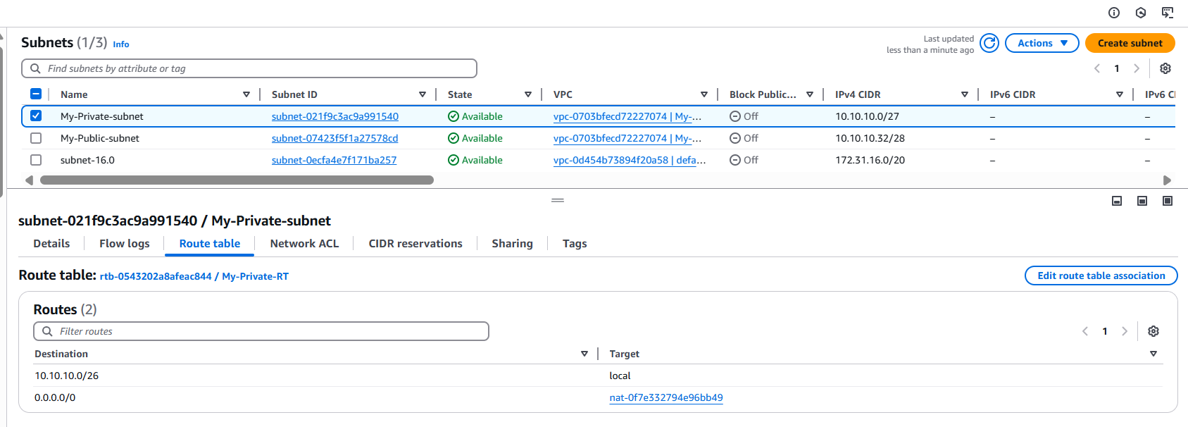
Step 11: lets validate,
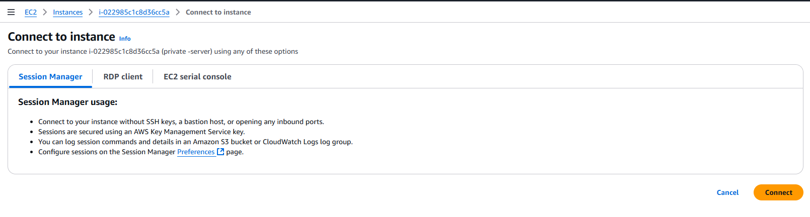
Now we could see that the error is gone and ssm agent is alone . without exposing to internet we establish internet access to instance . further lets login via session manager and validate.
And in fleet manager also we could see its running.
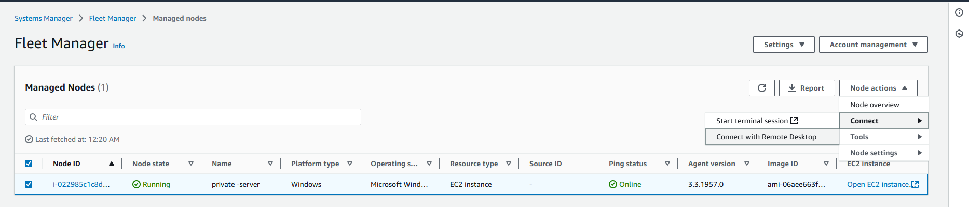
Connect with Remote desktop.
